WEEK 1 – DSA

Exercise 2: E-commerce Platform Search Function
Scenario:
You are working on the search functionality of an e-commerce platform. The search needs to be optimized for fast performance.

Steps:

1. Understand Asymptotic Notation
- Study Big O notation to analyze algorithm efficiency.
- Understand Best Case, Average Case, and Worst Case scenarios.
2. Setup
- Create a Product class.
- Add attributes:
1.productId
2.productName
3.category
3. Implementation
- Implement Linear Search algorithm.
- Implement Binary Search algorithm.
- Store products in an array.
- Use a sorted array for Binary Search.
4. Analysis
- Compare the time complexity of both algorithms.
- Determine the most suitable algorithm for an e-commerce platform.
Product Class:
//Product Class with the required Attributes
class Product{
int productId;
String productName;
String category;
Product(int productId, String productName, String category){
this.productId = productId;
this.productName = productName;
this.category = category;
}
public String toString(){
return productId + " " + productName + " " + category;
}
}
Ecommerce Search class
//Main Class
import java.util.*;

public class EcommerceSearch{
//Linear search - iterating through all the elements in the array
static Product linearSearch(Product[] products, String key){
for (Product product: products){

if (product.productName.equalsIgnoreCase(key)){
return product;
}
}
return null;
}
// Binary search - uses sorted array and splits the search space into half by comparing with mid element
static Product binarySearch(Product[] products, String key){
int left = 0;
int right = products.length - 1;
while (left <= right){
int mid = left +(right - left) / 2;
int compare = products[mid].productName.compareToIgnoreCase(key);
if (compare == 0) return products[mid];
else if (compare < 0) left = mid + 1;
else right = mid - 1;
}
return null;
}

public static void main(String[] args) {
Product[] products = {
new Product(101, "Laptop", "Electronics"),
new Product(102, "Shoes", "Fashion"),
new Product(103, "Phone", "Electronics"),
new Product(104, "Watch", "Accessories"),
new Product(105, "Camera", "Electronics")
};
String searchItem = "Phone";
System.out.println("Linear Search:");
Product result1 = linearSearch(products, searchItem);

if (result1 != null) System.out.println(result1);
else System.out.println("Not Found");

Arrays.sort(products, Comparator.comparing(p -> p.productName.toLowerCase()));
System.out.println("\nBinary Search:");
Product result2 = binarySearch(products, searchItem);
if (result2 != null)
System.out.println(result2);
else
System.out.println("Not Found");
}
}
OUTPUT:
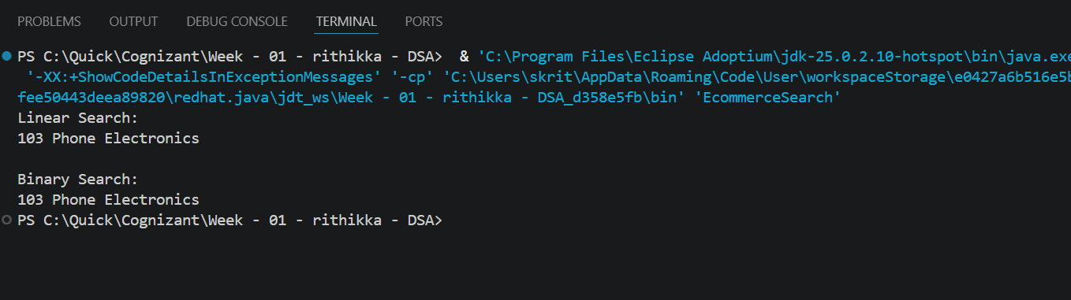
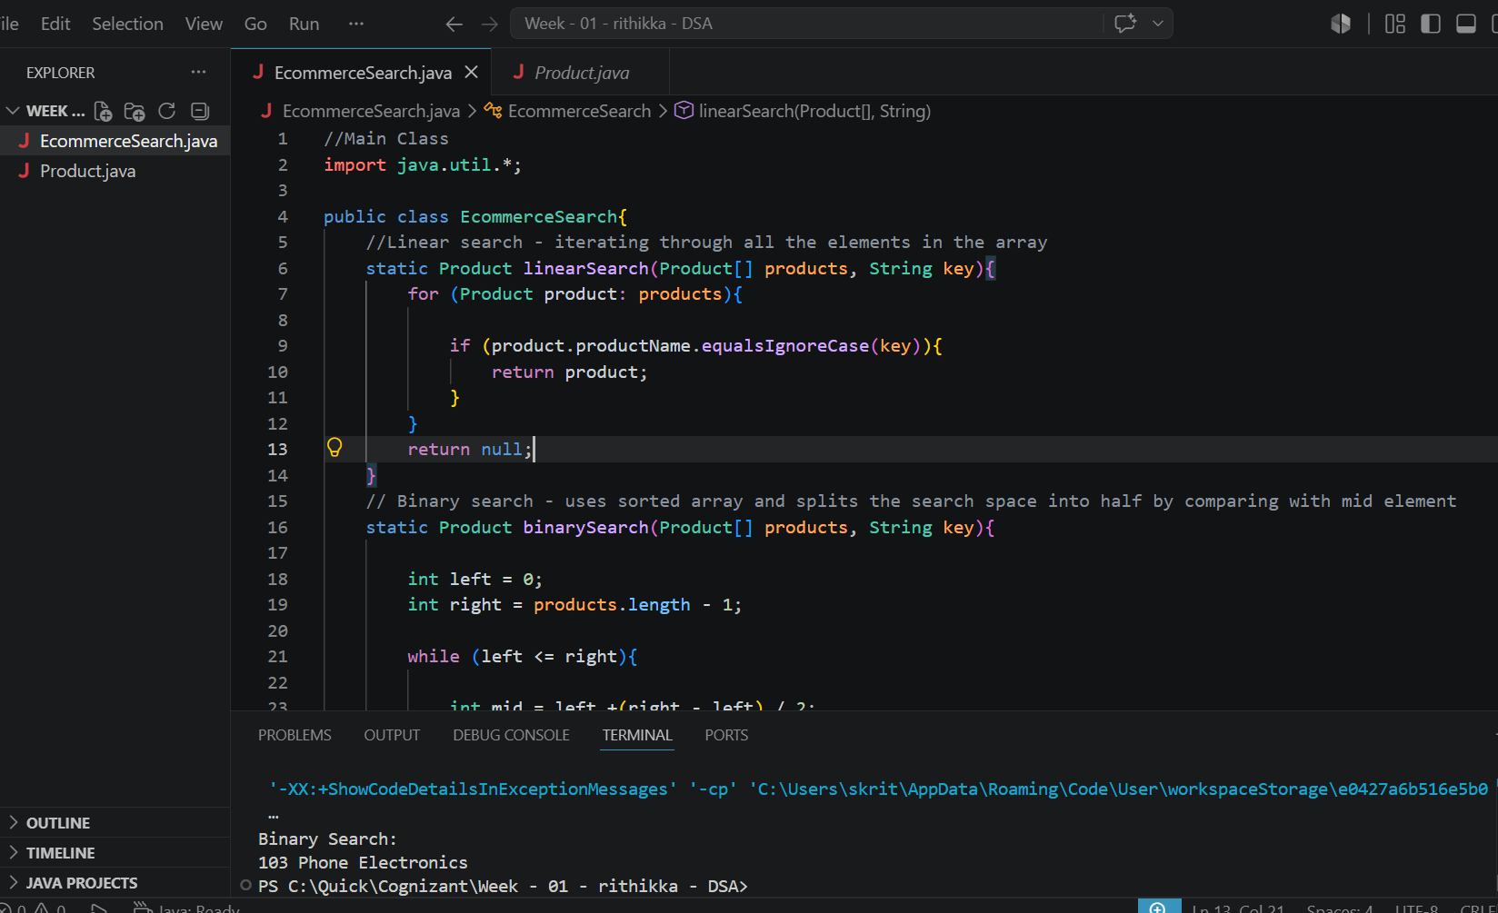
Exercise 7: Financial Forecasting
Scenario:
You are developing a financial forecasting tool that predicts future values based on past data.
Steps:
- Understand Recursive Algorithms
  - Recursion is a technique where a method calls itself to solve smaller instances of a problem.
  - It simplifies problems that can be broken down into repetitive subproblems.
- Setup
  - Create a method to calculate future values using recursion.
  - Use an initial investment amount and a growth rate.
- Implementation
  - Implement a recursive function that calculates the future value after a specified number of years.
- Analysis
  - Analyze the time complexity of the recursive algorithm.
Discuss optimization techniques.
Solution CODE:
FinancialForecast.java
public class FinancialForecast{
// Recursive method
static double futureValue(double investment, double growthRate, int years){
// Base case
if (years == 0) return investment;
// Recursive case
return futureValue(investment, growthRate, years - 1) * (1 + growthRate);
}
public static void main(String[] args) {

double investment = 10000;
double growthRate = 0.10; // 10%
int years = 5;
double result = futureValue(investment, growthRate, years);

System.out.println("Initial Investment : ₹" + investment);
System.out.println("Growth Rate : " + (growthRate * 100) + "%");
System.out.println("Years : " + years);
System.out.printf("Future Value : ₹%.2f", result);
}
}
OUTPUT:
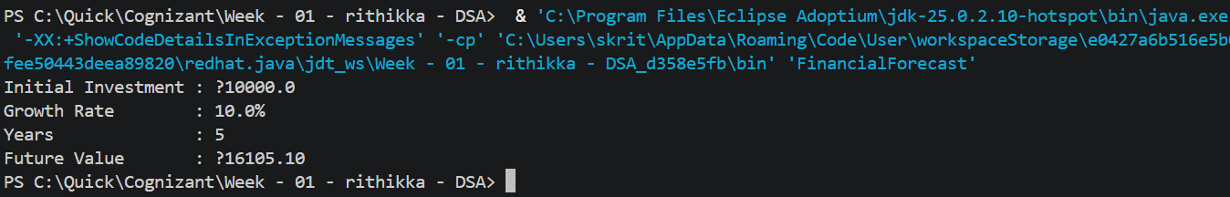
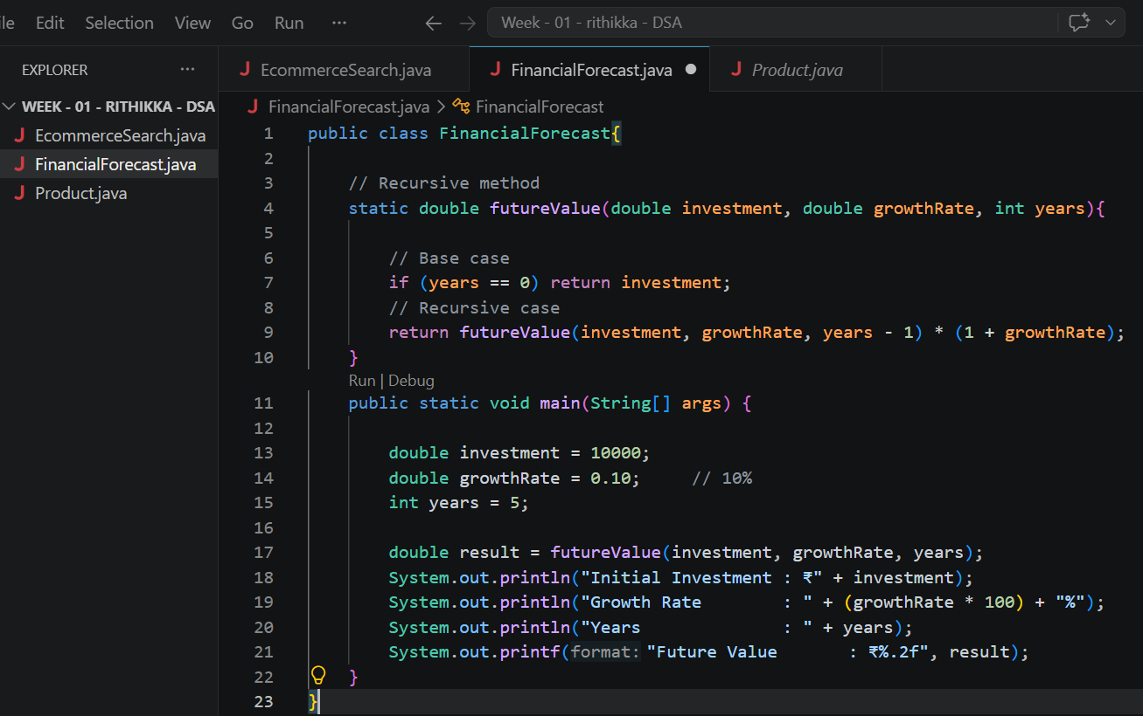
Time Complexity:
The recursive function is called once for each year.
If there are N years: T(N) = T(N−1) + O(1). Therefore, Time Complexity = O(N).
Space Complexity
Each recursive call occupies stack memory. Space Complexity = O(N)
Optimization Technique:
Mathematical Formula (Most Efficient)
Use the compound interest formula: Future Value = P × (1 + r)^n
Where:
- P = Initial Investment
- r = Growth Rate
- n = Number of Years
Time Complexity = O (1) (conceptually, using the library function)
Space Complexity = O (1)

